Process Monitor Repository located @ :

<https://github.com/PeeWee2000/ProcessMonitorOSA>

Download via the download as zip button:

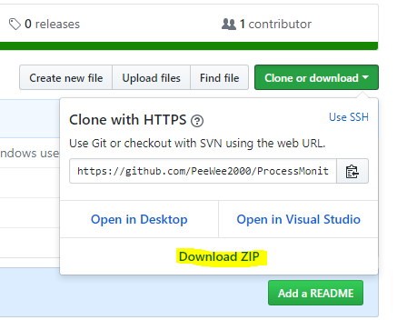

Notes: [Linux Users will need to install .Net Core 2.0](https://docs.microsoft.com/en-us/dotnet/core/linux-prerequisites?tabs=netcore2x) -- Once it is installed copy the root folder with ProcessMonitorOSA.dll file ([ProcessMonitorOSA\bin\Debug\netcoreapp2.0](https://github.com/PeeWee2000/ProcessMonitorOSA/tree/master/ProcessMonitorOSA/bin/Debug/netcoreapp2.0)) and run the dll with .netcore with this command: **dotnet ProcessMonitorOSA.dll**

Windows users should use the precompiled Binary located in [ProcessMonitorOSA\bin\Debug\netcoreapp2.0\win-x64](https://github.com/PeeWee2000/ProcessMonitorOSA/tree/master/ProcessMonitorOSA/bin/Debug/netcoreapp2.0/win-x64)

Usage Notes:

It is advisable to let the program run in monitor mode (command line text will all be blue) for at least 15-30 minutes to make sure any system critical background processes are captured.

This program has 3 steps:

1. Log all currently running processes to a specified file
2. Continue to monitor for new processes (e.g. once every 10 minute background processes) and write them to the same log file
3. Once the log has been generated monitor the OS for any processes that are not in the log file (whitelist) and kill them